Conquer Addiction Excellence in Treatment Application –
Sample September 2022 12 Month Submission

Submit your outcomes research results to Conquer Addiction by clicking here.
Applications must be submitted by 5:00 p.m. PST (8:00 p.m. EST) on Thursday, September 15, 2022

Treatment Center Information
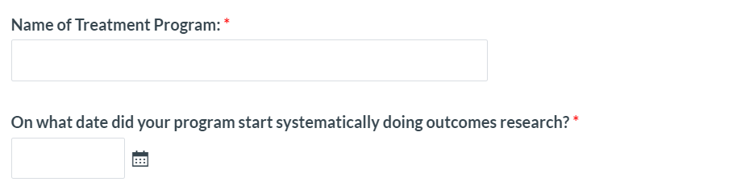
Apollo Recovery
01/01/2020

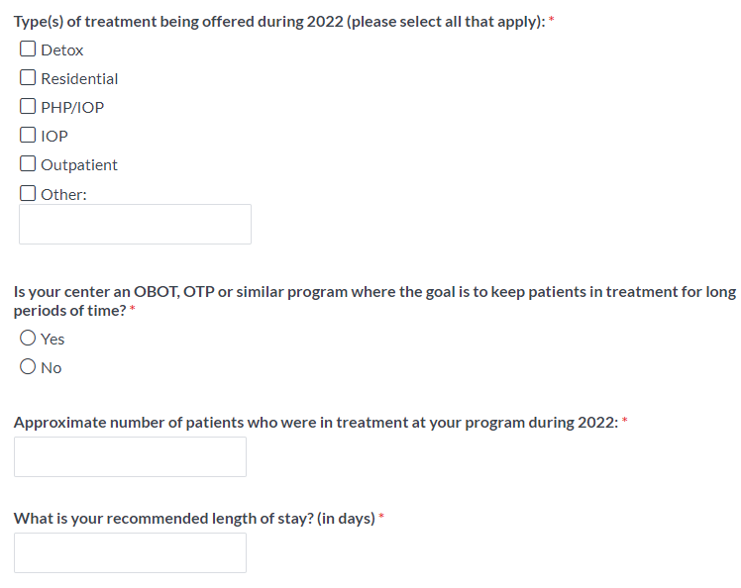
Please fill in this basic information about your treatment program

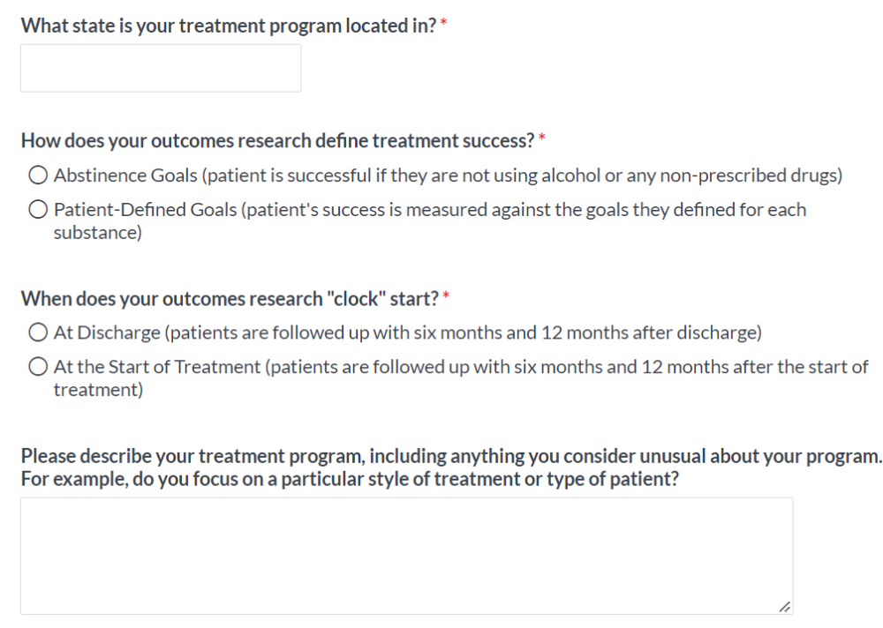
Complete

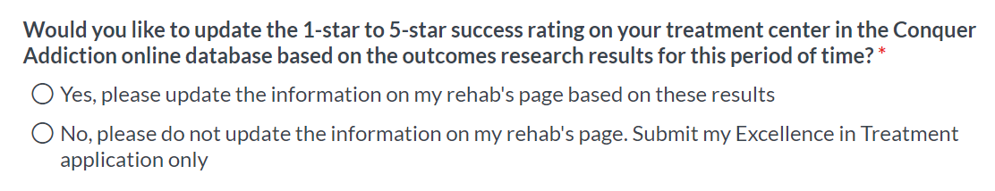

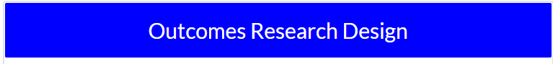

Please describe in specific terms how your outcomes research was conducted:

Describe here

You will see one of the following two options:

OR

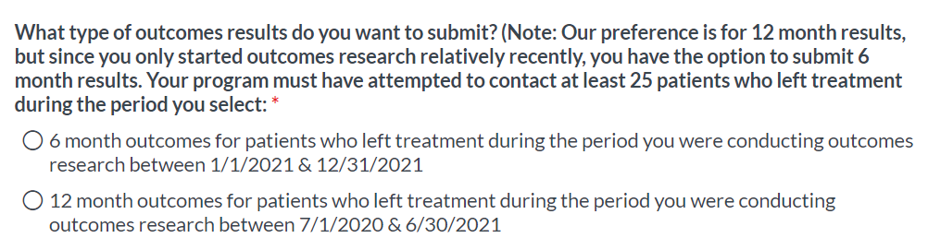
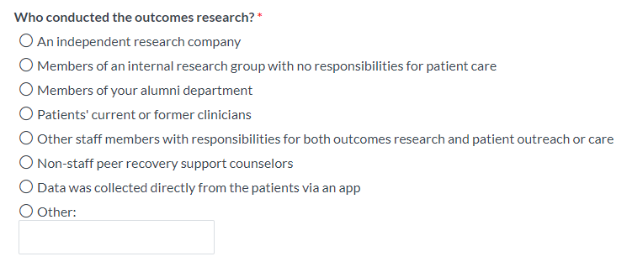

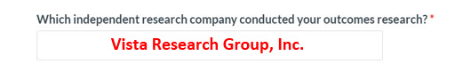
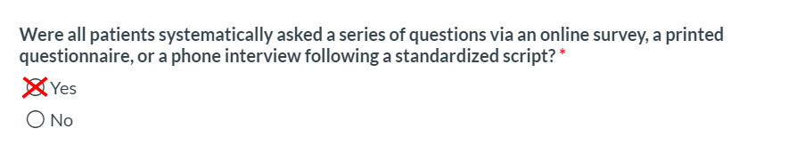

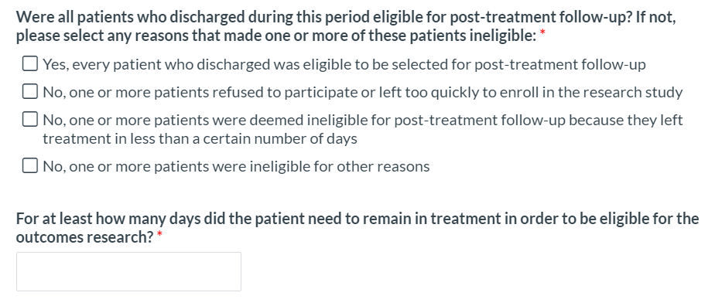
7
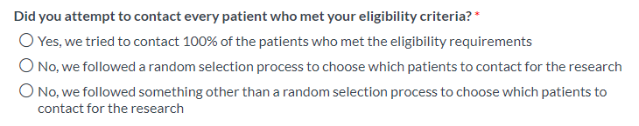
You may see this question:
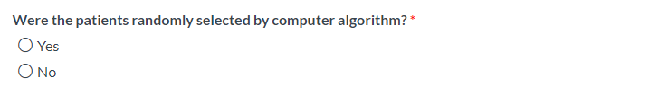
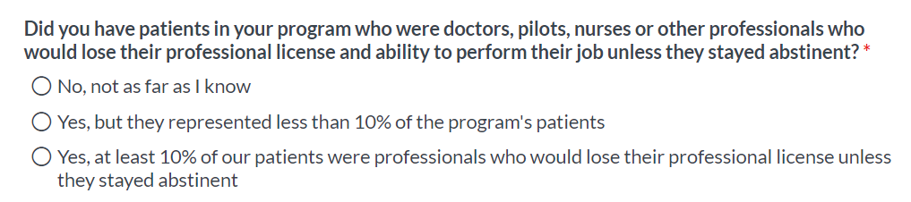
Select the correct response

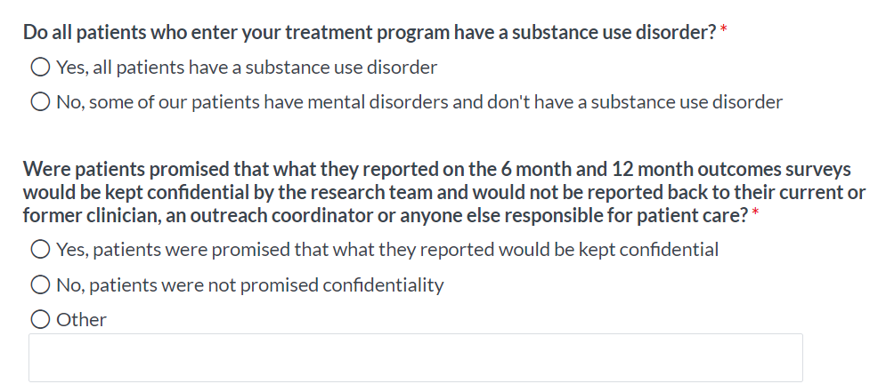
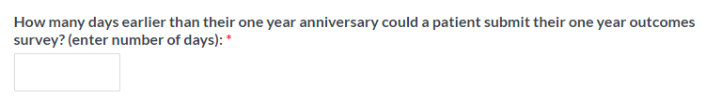

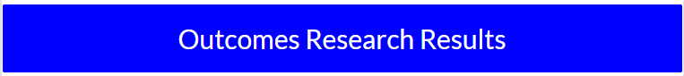

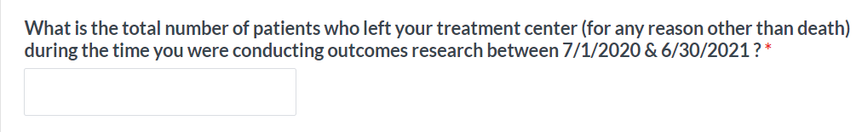
= ? + 3 + 156

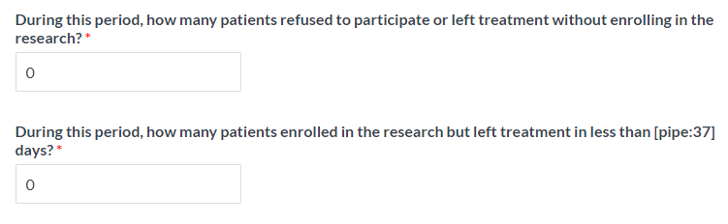
3
?
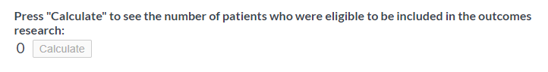
156
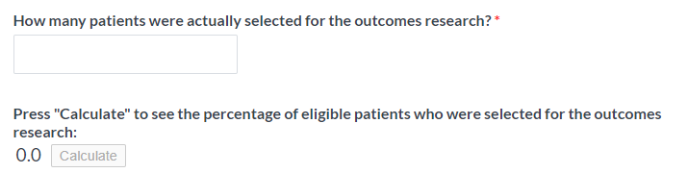
139
89

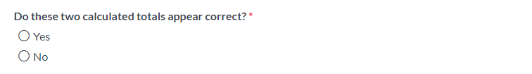
Only behavioral centers will be asked this
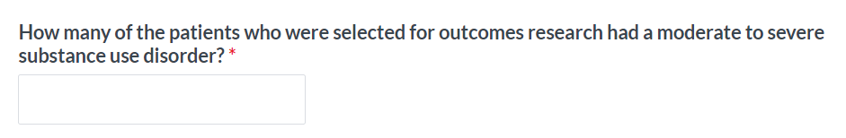

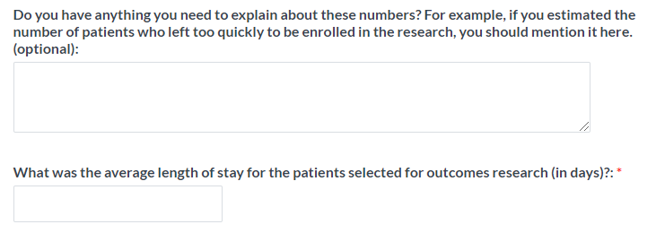
69
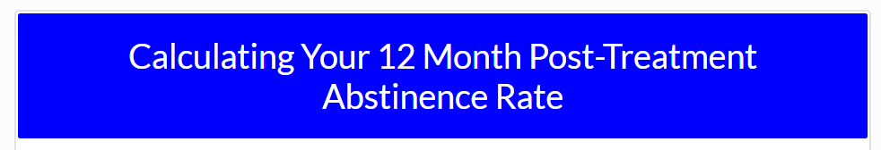
Among this total number of patients whom you attempted to contact at one year post-treatment, please enter the number of patients who reported this abstinence success:

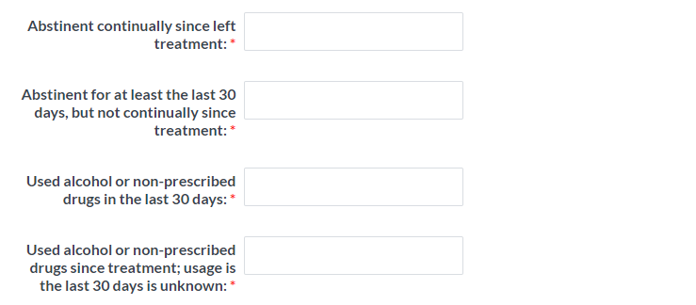
0
7
18
30
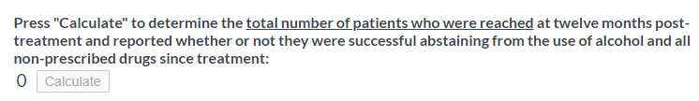
55
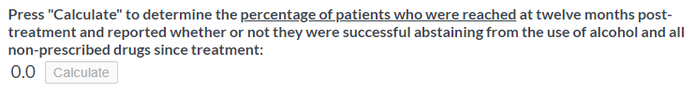
39.6

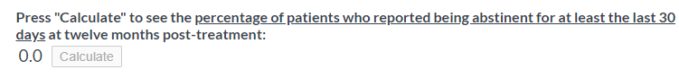
34.5

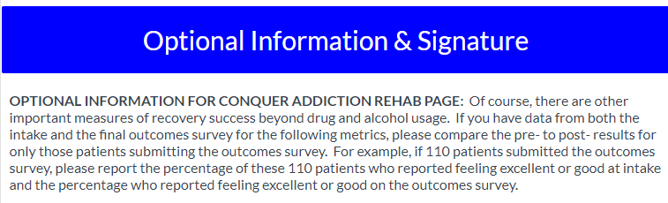

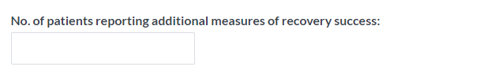
55
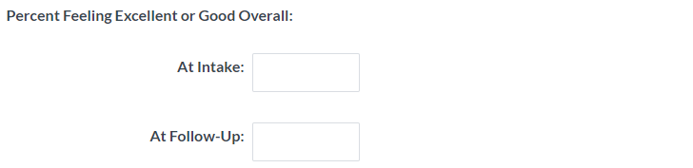
7
73
95
73

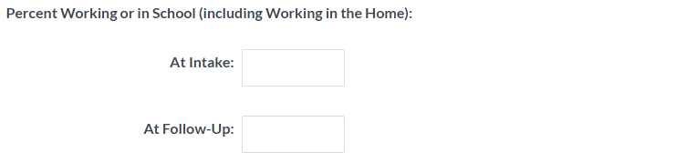
89
62

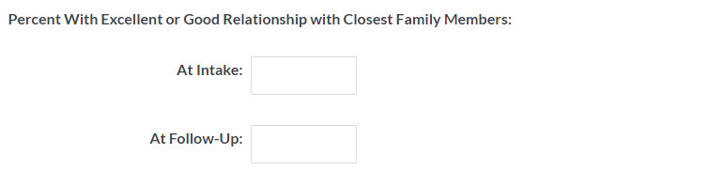
73
20

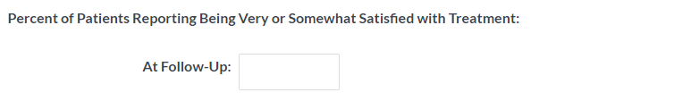
80

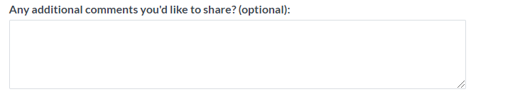

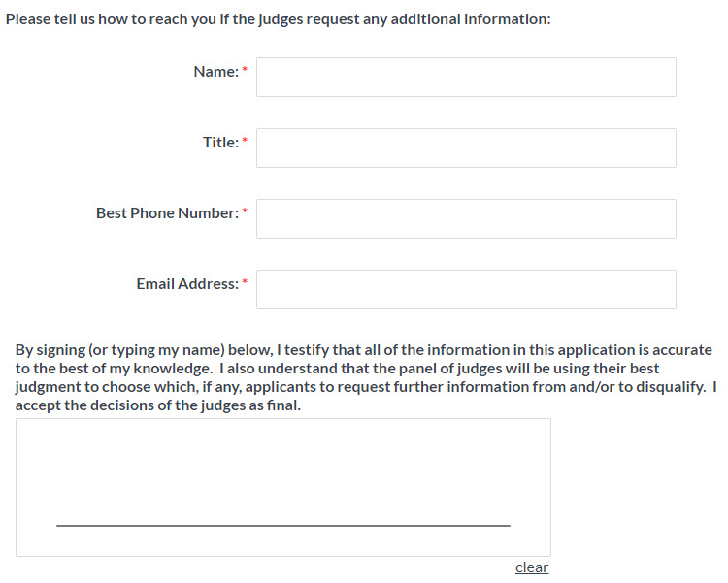
Finally, please provide your contact info & testify that the data is accurate

